# PRN : 2019BTECS00102

# Name: Pratik Babaso Chougule

# Subject: PL3 Assign 5B

GITHUB LINK:

**Problem Statement 1:**

Design and develop a static web page using HTML for **IPL blog**. Access it locally and in LAN using a web server.

It should have following sections:

1. Header – Title and authorship information of a blog
2. Three links to other technical blogs
3. Article – At least two articles should be there
4. Contact Information of author It should have following tags:

CODE:

<!DOCTYPE html>

<html lang="en">

<head>

    <meta charset="UTF-8">

    <meta http-equiv="X-UA-Compatible" content="IE=edge">

    <meta name="viewport" content="width=device-width, initial-scale=1.0">

    <title>Blog on IPL by Pratik</title>

    <style>

        ul{

            display: flex;

            flex-direction: row;

        }

        li{

            padding: 20px;

            list-style: none;

        }

        #footer{

            padding: 30px;

            text-align: center;

        }

        #extra{

            text-align: center;

        }

    </style>

</head>

<body>

    <nav id="navbar">

        <ul>

            <li><a href="/HOME">Home</a></li>

            <li><a href=".LP">Latest Posts</a></li>

            <li><a href="/FP">Finals Prediction</a></li>

        </ul>

    </nav>

    <h1>Blog on IPL by Pratik Chougule</h1>

    <section id="sec1">

        <h2> Who will win the Finals (CSK or KKR)? Finals Prediction with team members</h2>

        <p>

            As we know current stats that total matches played between <strong> KKR and CSK </strong>are 24 out of which CSK has won 18 matches.

            CSK has good winning probability. But this time all players in KKR are performing wll so thinking about winner

            is difficult.

        </p>

        <img src="csk.png" alt="">

        <h2>RCB was having a chance but they lost and virat kohli will not be captain of RCB next IPL?</h2>

        <p>

            <em> Virat kolhi</em> told that he was having good experience while being the captain of RCB and they have struggled a lot to peform

            After getting eliminated in the qualifier 2 they were feeling bad but having satisfaction of playing well this season as told by other team members

        </p>

        <h2>3 players who could be the new RCB captain in IPL 2022</h2>

        <p>IPL 2021 was another heartbreak for Royal Challengers Bangalore and their fans. RCB were defeated by the Kolkata Knight Riders by four wickets in the Eliminator. RCB played some very good cricket in the first-half of IPL 2021 and won four out of the seven games in the UAE leg, finishing up in third position.

        RCB skipper Virat Kohli, before the start of the UAE leg, announced that this will be his last season as RCB skipper. Now that the asonis over for the Bangalore boys, Virat Kohli has stepped down as the captain of the franchise and RCB will be looking for someone who canlead the team from the next IPL.</p>

    </section>

    <section id="extra">

        More Related Blogs <a href="https://cricblog.net/news-3-players-who-could-be-the-new-rcb-captain-in-ipl-2022/"> Who will be next RCB captain</a>

        <a href="https://www.predict22.com/cricket/blog/tournament/IPL%202021/">         Predict the finals here</a>

        <a href="https://www.firstpost.com/tag/ipl-2021"> Latest news about IPL teams</a>

    </section>

    <br>

    <footer id="footer">

        Contact: <a href="pratikchougule33@gmail.com">Mail Us</a> Phone Number: <a href="7028196008">Call Us Now</a>

    </footer>

</body>

</html>

Screenshots:

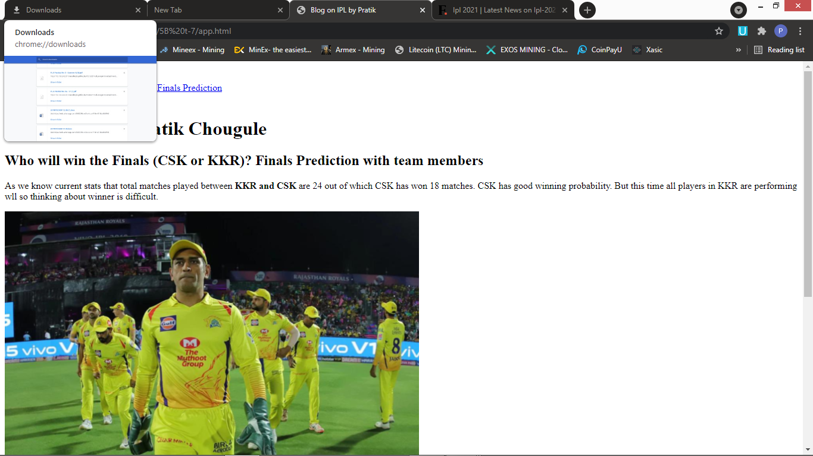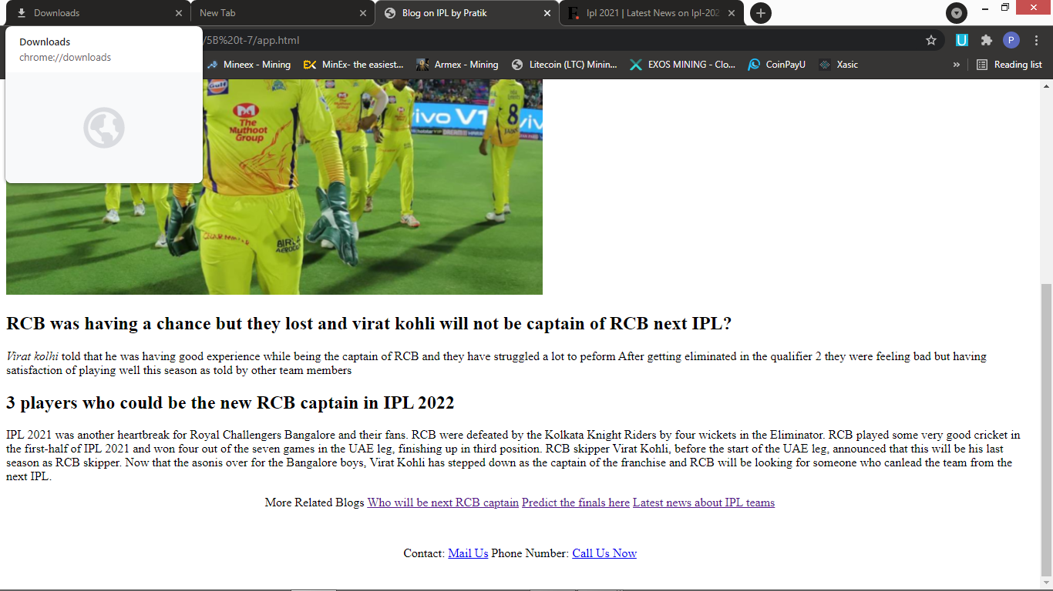

**Problem Statement 2:**

Design and develop a static web page using HTML for following requirements. Access it locally and in LAN using a web server.

It should have following sections:

1. Problem Statement: Write a code in any programming language that counts the digits in a number..
2. Code
3. Sample Input
4. Sample Output
5. Variables used in the program
6. Complexity

CODE:

<!DOCTYPE html>

<html lang="en">

<head>

    <meta charset="UTF-8">

    <meta http-equiv="X-UA-Compatible" content="IE=edge">

    <meta name="viewport" content="width=device-width, initial-scale=1.0">

    <title>problem 2</title>

</head>

<body>

    <h1>CODEWITHPRATIK</h1>

    <header>

        <section>

            <p>

            <h2>

                Code in any c++ language that can count the number of digits.

            </h2>

            </p>

            <p>

                divide the number by 10 and increment ans variable by 1 till n>0

            </p>

        </section>

    </header>

    <main>

        <p><b>Sample code</b></p>

        <pre>

            <code>

  #include <iostream>

  #include <math.h>

  using namespace std;

  int main()

  {

     int n;

     cin>>n;

     int ans=0;

     while(n>0){

         ans++;

         n=n/10;

     }

  }

            </code>

        </pre>

        <p><b>Sample output</b></p>

        <samp>

        <pre>

    Input n varaible from user

    create while loop for n>0 :

    divide n by 10

    increment ans variable

            </pre>

        </samp>

        <section>

            <p>

                <B>Variables used in program-</B>

                <br>

                In the above code total 2 variables used.

                <br>

                <var>n</var> stores the number whose digits are to be found

                <br>

                Simillarly <var>ans</var> stores the count of digits in the number

                <br>

            </p>

            <p><B>Time Complexity-</B></p>

            <p>Since there is one loop so time complexity of above code is O(no of digits of)</p>

        </section>

        <hr>

        <p>

</body>

</html>

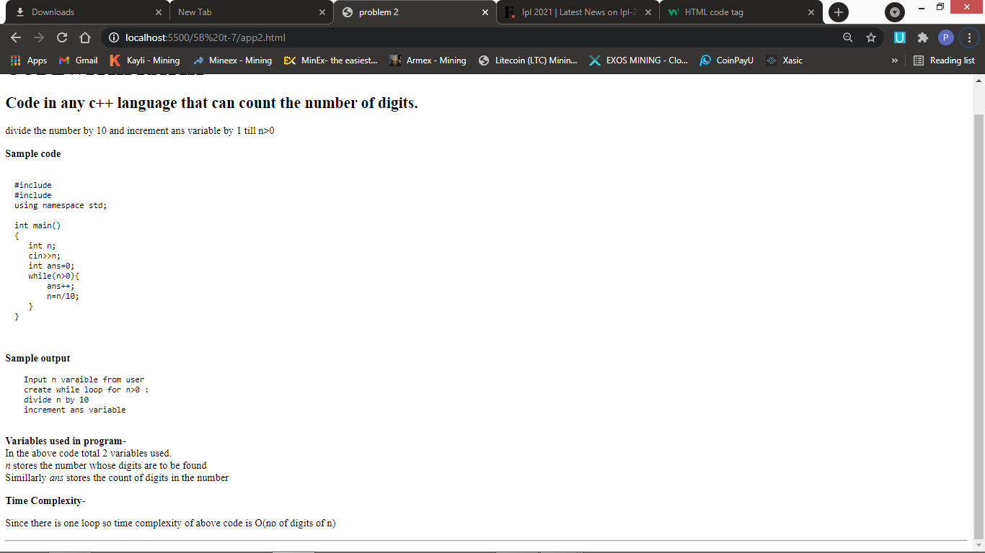

**Problem Statement 3:**

Design and develop a static web page using HTML for following requirements. Access it locally and in LAN using a web server.

It should have following sections:

1. Any three quotes from https://www.brainyquote.com/ with the name of the person who quoted it.
2. <!DOCTYPE html>
3. <html lang="en">
4. <head>
5. <title>Brainy Quote</title>
6. </head>
7. <body>
8. <header>
9. <h1>
10. <q>Inspirational Quotes by famous Authors</q>
11. </h1>
12. </header>
13. <article>
14. <section>
15. <blockquote>
16. It is not from the benevolence of the butcher, the brewer, or the baker that we expect our dinner, but from their regard to their own interest.
17. <em>-Adam smith</em>
18. </blockquote>
19. </section>
20. <section>
21. <blockquote>
22. I done wrestled with an alligator, I done tussled with a whale; handcuffed lightning, thrown thunder in jail; only last week, I murdered a rock, injured a stone, hospitalised a brick; I'm so mean I make medicine sick.
23. <em>-Muhummad Ali</em>
24. </blockquote>
25. </section>
26. <section>
27. <blockquote>
28. Self-confidence has always been one of my good qualities. I am always very confident. It is in my nature to be confident, to be aggressive. And it applies in my batting as well as wicketkeeping.
29. <em>-M.S.Dhoni</em>
30. </blockquote>
31. </section>
32. </article>
33. <footer>
34. <h2>
35. <a href="https://www.brainyquote.com/">Wannt To Know more Interesting Things</a>
36. </h2>
37. </footer>
38. </body>
39. </html>

SCREENSHOTS:

